# **Zomato Restaurant Expansion Analysis**

**By Neha Kumari**

**Objective Questions**:

1. **What is the total no. of tables present in the data?**

* 2 Tables are present in workbook

“Zomato_Data_1-

Raw data & Country description

1. **What is the total no. of attributes present in the data?**

* 21 attributes are present in the data

1. **How many categorical columns are there in the data? [Search about categorical and continuous data, and try to answer this question]**

* Categorical data is a type of data which stores data into groups or categories using names or labels.
* 16 categorical columns are there in Raw Data and 2 in Country Description

RestaurantID

RestaurantName

CountryCode

City

Address

Locality

LocalityVerbose

Cuisines

Currency

Has_Table_booking

Has_Online_delivery

Is_delivering_now

Switch_to_order_menu

Price_range

Country

Country_Code

1. **The data consists of some inconsistent and missing values so ensure that the data used for further analysis is cleaned.**

* Replaced the inconsistent value
* Cuisines with blank values are removed using the feature that is “*Go-To Special”* which helps us check and remove the blanks or any inconsistent values.
* Deleting the blank rows as the data is too large, it will not have much effect on the data as it.
* Checked and removed any duplicates.

1. **Using the LookUp functions, fill up the countries in the original data using the country code.**

* Formula used for populating the value of country in the new column named country
* =VLOOKUP($C3,'country description'!$A$1:$B$16,2,0)

1. **Create a table to represent the number of restaurants opened in each country.**

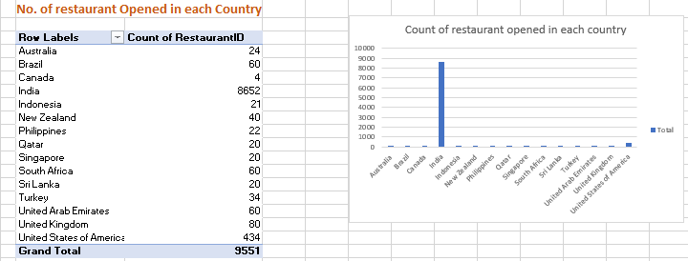



1. **Also, the management wants to look at the number of restaurants opened each year, so provide them with something here**.

* Created a pivot table to summarize the data that shows the no of restaurants that opened year wise.

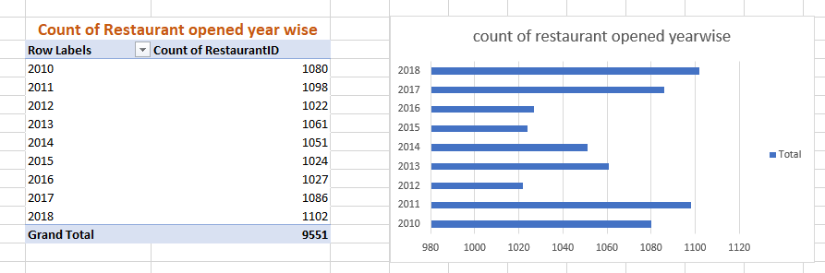



1. **What is the total number of restaurants in India in the price range of 4?**

* By using the formula
* “=COUNTIFS('Raw Data'!P:P,"=4",'Raw Data'!W:W,"India")”
* 388

1. **What is the average number of voters for the restaurants in each country according to the data?**

* The average votes in each country can be visualized using the pivot table and pivot chart.

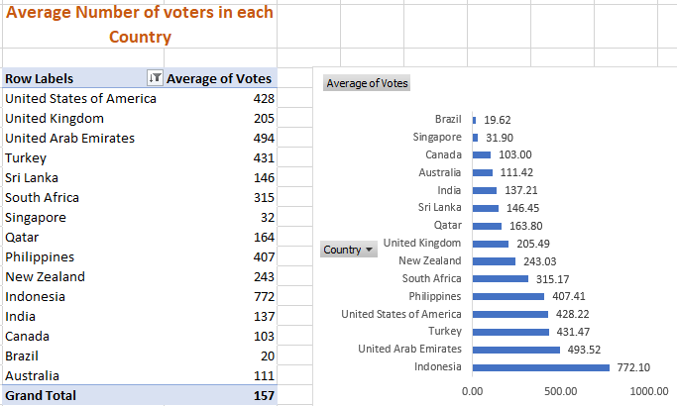



1. **Calculate the average rating for all the restaurants that have price_range < 4 and provide online delivery. Use only the “IF” function, Logical Operators, and Aggregation functions to solve this problem. [Note: Don’t use Conditional aggregation in this question.]**

* By using
* array formula(Ctrl+Shift+Enter)
* logical operator “if”,
* aggregate function “average”
* and rounding to 1 decimal place
* **{=ROUND(AVERAGE(IF(('RawData'!$P:$P<4)*('RawData'!$M:$M="Yes"),'RawData'!$S:$S)),1)}**

**3.3** is the Average Rating

1. **Using Conditional formatting highlight the rows of restaurants that are located in the countries or cities that you’ve suggested to the management for opening new restaurants.**

* Used conditional formatting -New Rules-Format only cell that contains- Australia/Canada, Singapore/Sri Lanka.

1. **Create a new customized price column that consists of the abbreviation/symbol of the currency along with the Average_cost_for_two value. [Use string operations to do this task]**

* Created a new column that consists of the conversion unit of currency for the countries in the Sheet “Country Description” -C1:C16 used this to calculate the average cost for two in INR.
* Used this formula to to find the average cost for two and added symbol of INR using the number format- currency
* =VLOOKUP($W2,'country description'!$B$1:$C$16,2,0)*R2

1. **How can you create an array formula in Excel or Google Sheets to count the number of restaurants listed that do not offer online delivery, are in the lowest price range, and have an average cost for two people less than or equal to 250 Indian Rupees?**

* Using array formula (Ctrl+Shift+Enter)
* {=SUM(IF(('Raw Data'!M:M="No")*('Raw Data'!P:P=1)*('Raw Data'!Y:Y<=250),1,0),1,1)}

1696

**Subjective Question:**

1. **Suggest a few countries where the team can open newer restaurants with lesser competition. Which visualization/technique will you use here to justify the suggestions?**

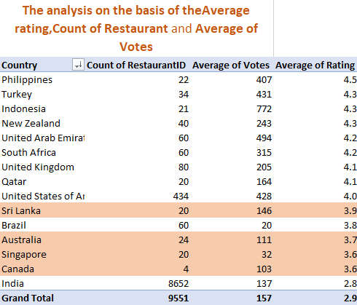

**Analysis and Approach**

* Best location to open the restaurant will be where the rating is high with a lesser count of restaurants.
* Based on the analysis and observation considering the criteria such as:
* average rating <4.0 and >3.5
* We get Sri Lanka, Brazil, Australia,Singapore, Canada, India
* Now by considering the second factor that is, where count of Restaurant is less which decreases the competition and increases the success rate so, eliminating the countries with high restaurant count we get these countries for expansion
* Sri Lanka
* Singapore
* Canada
* Australia

1. **Come up with the names of States and cities in the suggested countries suitable for opening restaurants.**

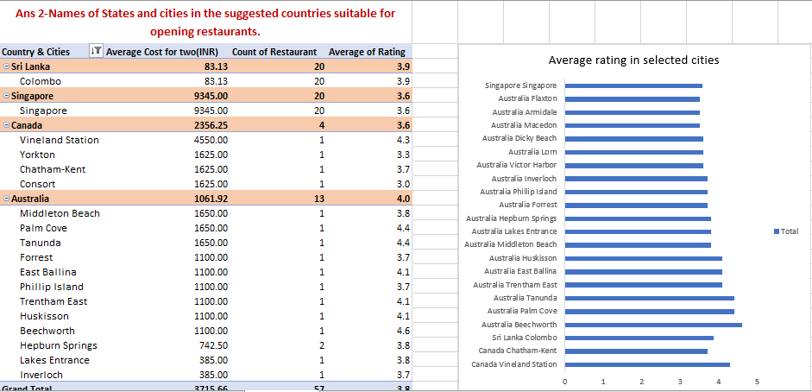

**Analysis and Approach**

* By considering three factors to determine which cities are best suited in the suggested countries for opening a restaurant are
* Higher average cost for two which will help generating better revenue
* Having least restaurant count
* Having rating above average i.e., “>3.5”
* Based on the above visualization and analysis Colombo in Sri Lanka, Singapore in Singapore, Vineland Station in Canada,Palm Cove, Tanunda, East Ballina are best suited in Australia for opening restaurants.

1. **According to the countries you suggested, what is the current quality regarding ratings for restaurants that are open there?**

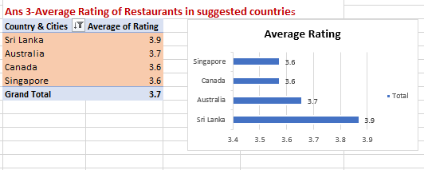

**Analysis and Approach**

* The dataset shows that the average ratings for restaurants in the countries under consideration range from 3.6 to 3.9**.**
* **Sri Lanka** has the highest average rating of 3.9.
* **Singapore** has the lowest average rating of 3.6.
* Despite the difference in ratings, all of these countries are showing positive trends, with ratings between 3.6 and 3.9 indicating generally good restaurant quality.
* **Sri Lanka** (with the highest rating) could be seen as a country with potentially more well-established or upscale restaurant offerings, or a market with higher standards in dining.
* **Singapore**, while having the lowest rating in this dataset (3.6), still performs well compared to global averages. A rating of 3.6 could imply that while many restaurants are of good quality, there might be a few areas where customer satisfaction can be improved (perhaps in service consistency or food quality).
* The variation between the highest and lowest countries is not drastic, showing that the restaurant industries in these countries are generally solid, though there may be room for improvement in certain markets.

1. **Also, what is the current expenditure on food in the suggested countries, so we can keep our financial expenditure in control?**

**Analysis and Approach**

Based on the analysis of restaurant ratings and food expenditure across the suggested countries:

* The cost of opening a restaurant or dining out will depend significantly on the local economic environment, the type of restaurant being opened, and the target customer base.
* To keep the expenditure under control, we can consider focusing on mid-range markets in both Sri Lanka and Singapore, where costs remain more predictable and affordable for customers while still providing quality experiences.
* By controlling inventory, labor costs, and choosing the right location, we can maintain profitability in both high-expense countries (like Singapore) and lower-cost countries (like Sri Lanka).
* The overall average cost for two is Rs 3379, whereas it ranges from 83 to 9345.
* Sri Lanka with Rs. 83 having min average cost for two and Singapore leading with max average cost for two Rs. 9345 and so will expenditure on food will range between Rs 83 to 9345 for opening a restaurant in the suggested countries.

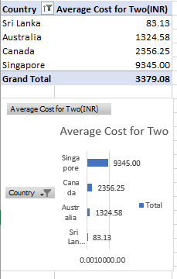

1. **Come up with the names of restaurants from the recommended states that are our biggest competitors and also those that are rated in the lower brackets, i.e. 1-2 or 2-3.**

* Biggest competitors for opening the restaurants are these cities based on their average rating that is between 3.5 and 4.0, considering them for better business and which will help us get a better command in the market and the customer.
* To establish a strong presence in the market and compete with these well-rated restaurants (3.5-4.0), we need to leverage the strengths of higher ratings while also addressing the weaknesses of the lower-rated spots
* When dealing with higher ratings we need to consider Quality Consistency, that our food quality and service remain consistently high. Customer reviews in Sri Lanka and Singapore emphasize the importance of service quality and value for money.
* Innovative Menu: Use fusion cuisines, create a signature dish, or focus on health-conscious options (e.g., plant-based or sustainable dishes) to differentiate yourself.
* Location: In countries like Sri Lanka, setting up in tourist hotspots like Colombo could drive foot traffic. In Singapore, choose trendy districts or business districts that appeal to both locals and tourists.
* 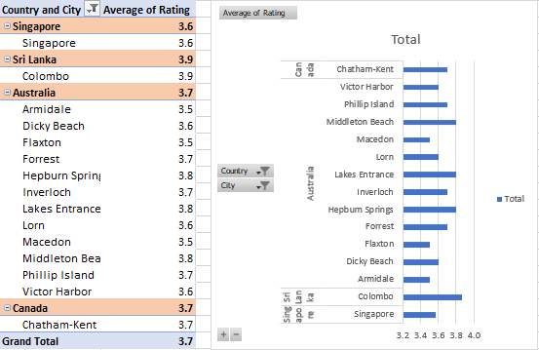
* 
* The Restaurants with rating 1-2 and

In the suggested countries there are no cities with rating between 1-2

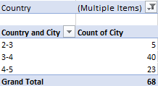

* with rating 2-3 are in

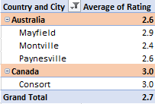

* + While dealing with lower rating brackets Service Excellence matters, restaurants in the 2-3 range fail due to poor service. By training your staff, focusing on customer engagement, and providing personalized experiences, you can stand out.
  + Ambience: Lower-rated restaurants might lack in ambiance or cleanliness, so a comfortable, aesthetically pleasing environment can elevate your restaurant’s rating quickly.
  + Value for Money: Offering an affordable yet quality menu will attract customers who are dissatisfied with lower-rated, overpriced options.

1. **Which cuisines should we focus on in the newer restaurants to get better feedback? Does the choice of cuisines affect the restaurant ratings?**

Have the list of restaurants with average rating above 4.0

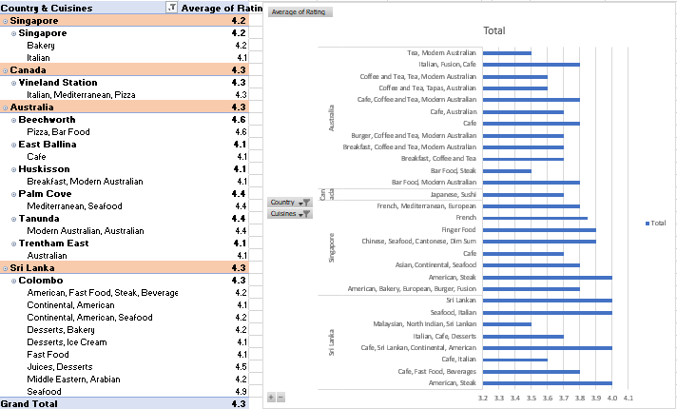



**Approach and Analysis**

* In order to attract a larger crowd, it’s essential to prioritize local and popular cuisines based on the specific location. Here’s a brief overview of the most popular cuisines in each region:
* **Singapore**: Italian and bakery items are highly favored, with a growing interest in fusion concepts.
* **Canada**: Italian, Mediterranean, and pizza are top choices, catering to diverse tastes.
* **Australia**: Pizza, Mediterranean, seafood, and modern Australian cuisine dominate, reflecting local preferences.
* **Sri Lanka**: American, fast food, steak, and continental dishes are most popular, along with a focus on beverages.
* By offering a menu that aligns with these local preferences while maintaining quality, consistency, and personalized service, restaurants can enhance customer satisfaction and ensure higher ratings.

1. **According to our current data, should we go for online delivery and table booking? Does that affect the customer’s ratings?**

* As per the data we can see that the selected countries(suggested for expansion) do not offer online delivery and online booking.

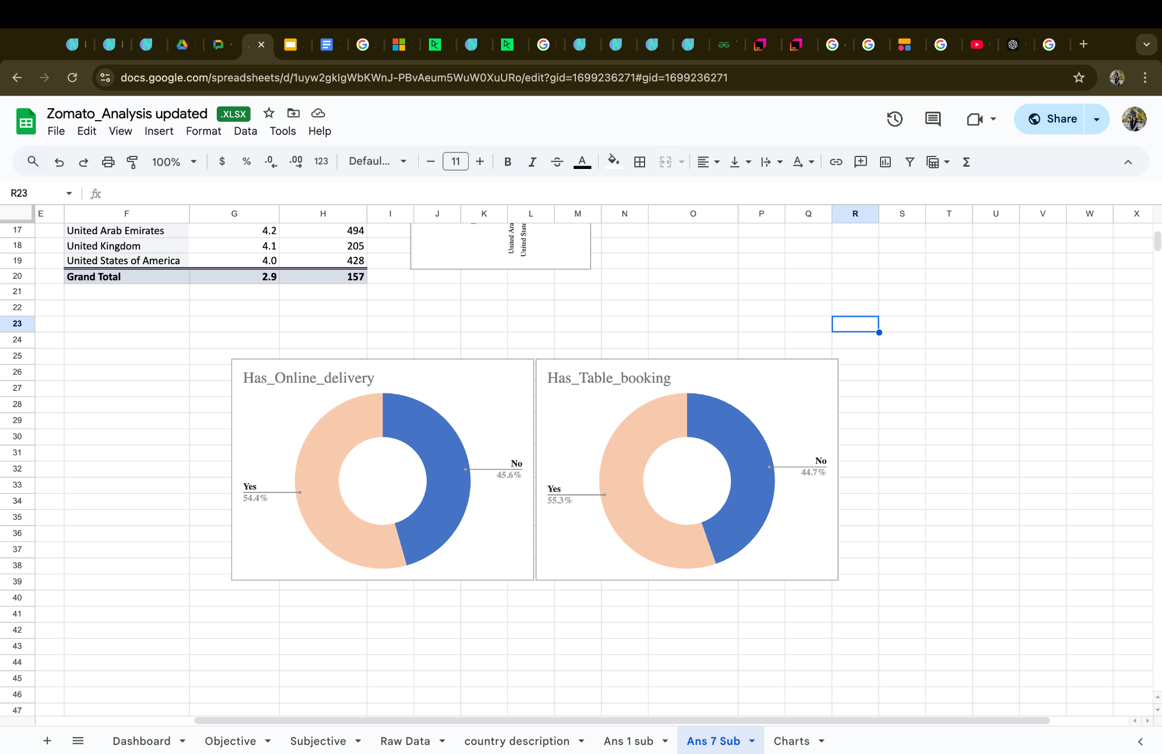

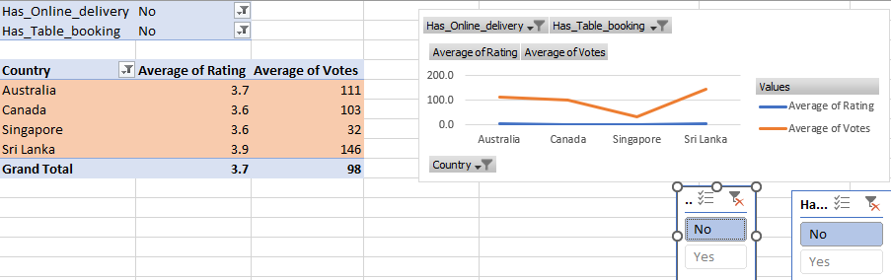

* The Countries which offer online booking and online delivery have a positive impact on the rating, the rating and votes are increasing.

The average rating is higher for those countries and votes are higher.

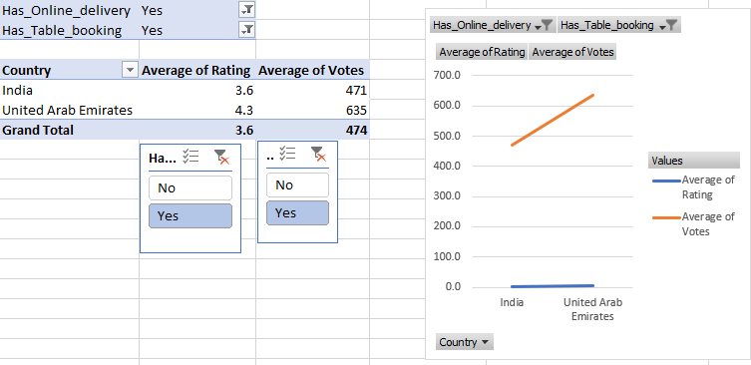

Same countries with online delivery and online table booking are having lower average ratings and votes.

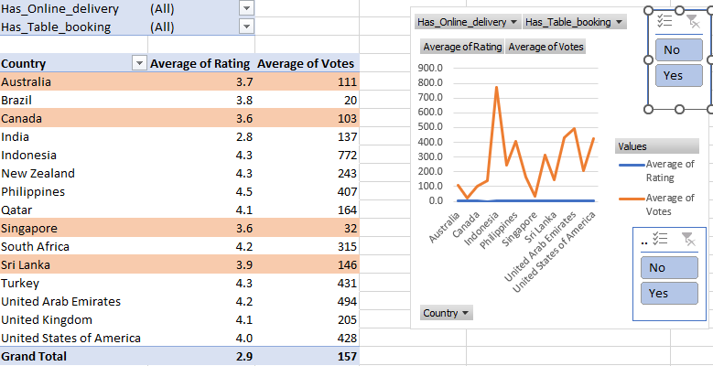

* So from all these data we can tell that the rating is being affected positively by the online services.
* For India it is 3.5 with online services and 2.4 without the online services.
* So, it has a positive impact on the restaurants.
* And we can go for online booking and online delivery in the suggested countries as this will be a new option to explore and expand the mode of business.

1. **Should the team keep the rate of cuisines higher? Will that affect the feedback? According to our data are the rates of cuisines and ratings, correlated?**

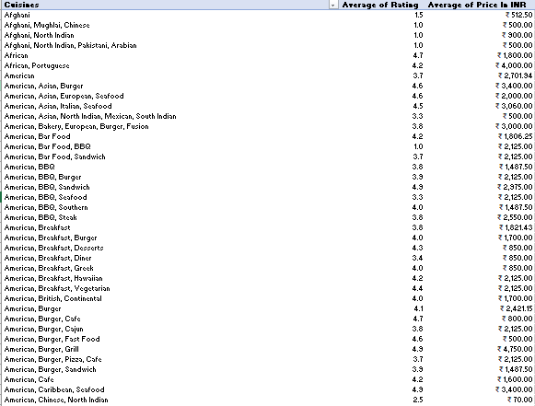

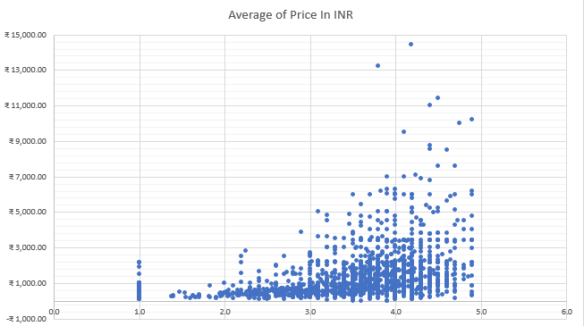

* From the graph we can depict that as the rating of cuisines is increasing the average cost for two is also increasing.
* For the cuisines with higher rating i.e., above 3.5 the cost is increasing, so we can conclude that the high rating cuisines have average cost higher.
* Calculated the correlation coefficient
* “=CORREL(F3:F1829,G3:G1829)”

0.334074243.

* This Correlation indicates a positive relation between the cuisine average rating and the average cost for two.
* But the relationship is not very strong, with an increase in the rating the price range is also increasing.

1. **What is the distribution of the number of restaurants of different price ranges in all the countries?**

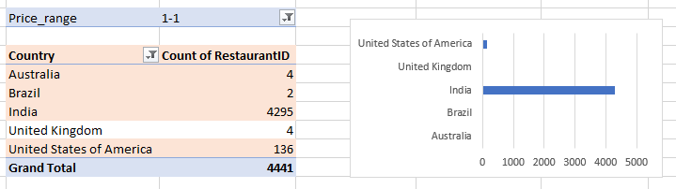



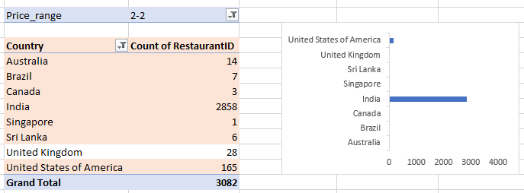



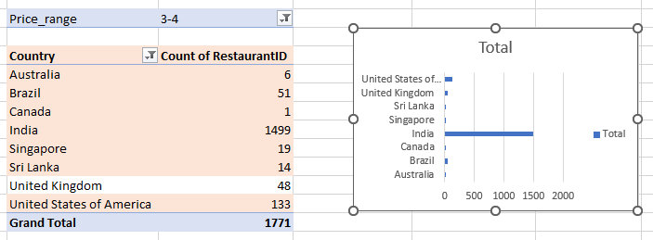



* Based on the data we can see the count of restaurants with different price ranges in different cities.
* In the price range of 1:
* Australia has 4 restaurants,Brazil has 2,India 4295, UK 4, USA 136.
* In price range of 2:
* Australia has 14 restaurants,Brazil has 7,Canada 3,India 2858, UK 28, USA 165,Singapore 1, Sri Lanka 6.
* In price range of 3-4
* Australia has 6 restaurants,Brazil has 51,Canada 1,India 1499, UK 48, USA 133,Singapore 19, Sri Lanka 14.

1. **Explain your approach in brief for suggesting countries/cities in order to open new restaurants, if the objective and subjective questions would have not been given to assist you. [you have to give bullet pointers in order to answer this question]**

* My approach in determining the countries and cities in order to open new restaurants are
* Determining which Countries would be a better option by considering the factors such as the “Average Rating >4”,”Count of restaurants is low”,”Average votes is high”.
* Then I started to determine which cities are best suited in the suggested countries for expansion those having higher average cost for two which will help generating better revenue, having least restaurant count and having rating above average i.e., “>3.5”
* After determining the cities, identify the cuisines that are most popular and have high rating and higher average cost for two which will help us generate better revenue. As the cuisine that is already in demand will also help in attracting a better crowd.

